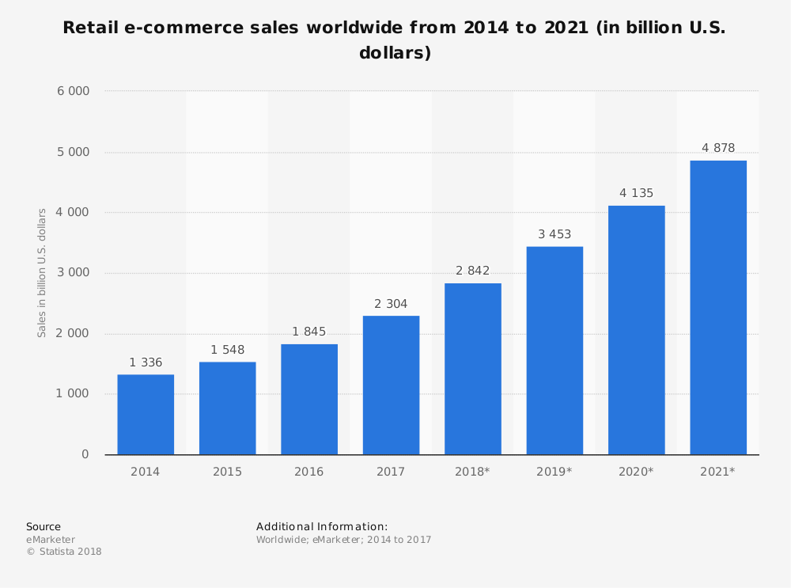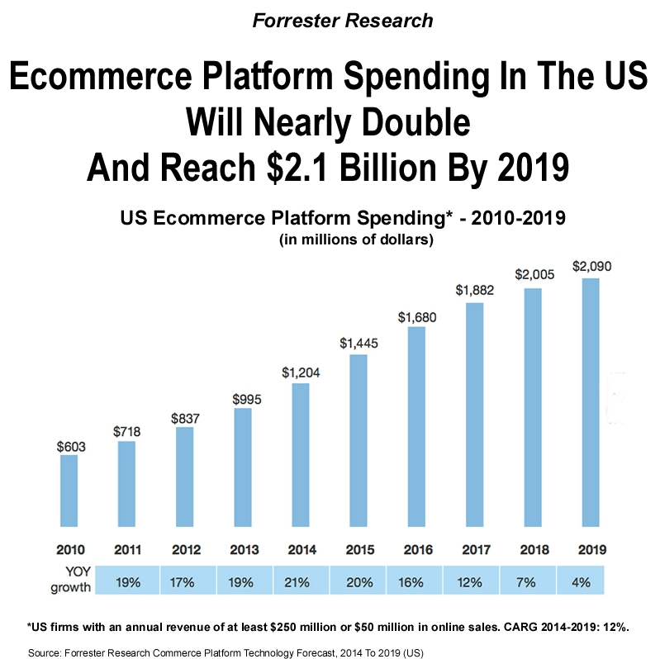

Revenue from Devices

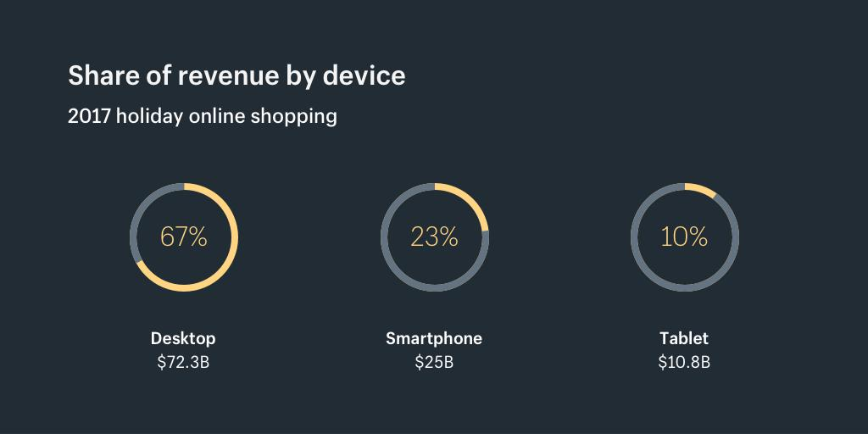

*Data via Adobe Digital Insights*

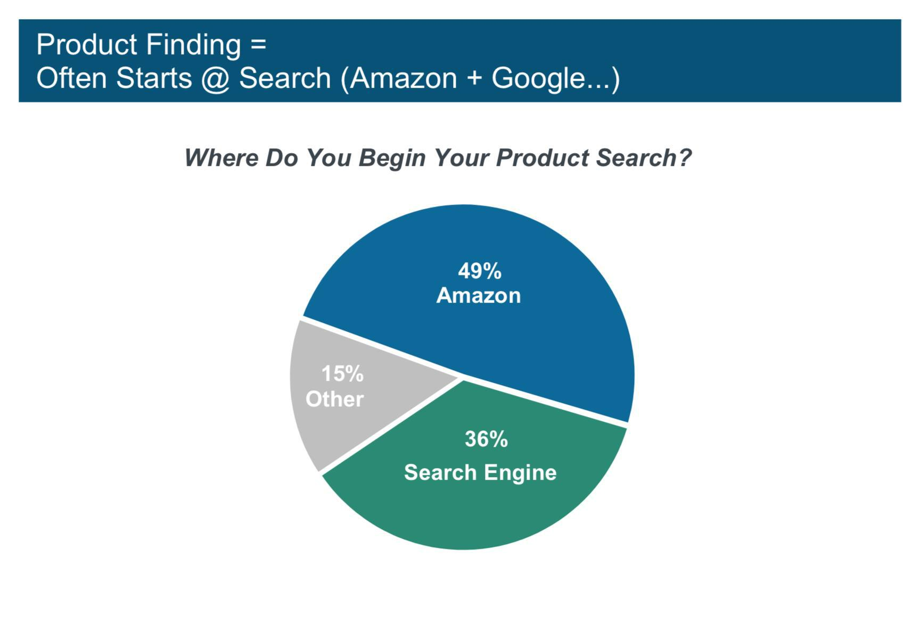

Half of all product searches now start on Amazon

*Data from the Mary Meeker Report*

Messaging app usage surpassed social networks for the first time in 2016 as well.

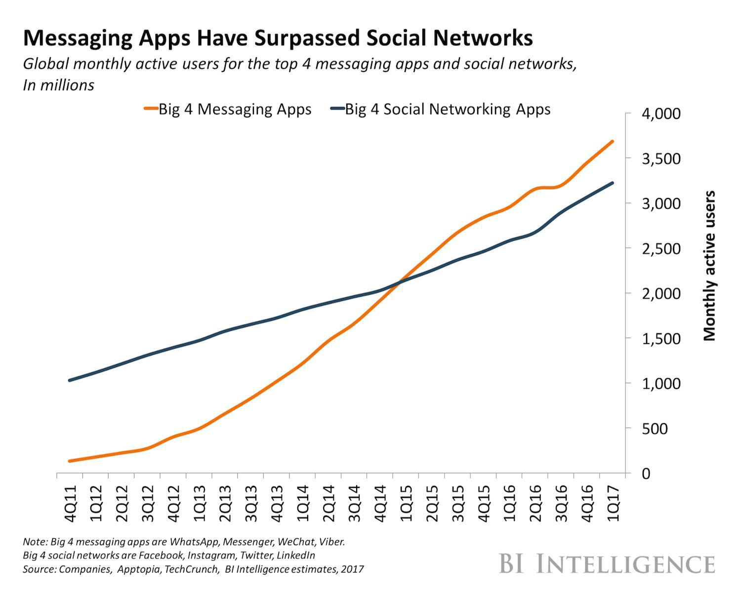

China’s off-the-charts growth forecasts that their total ecommerce sales are expected to double in three years, adding $1 trillions.

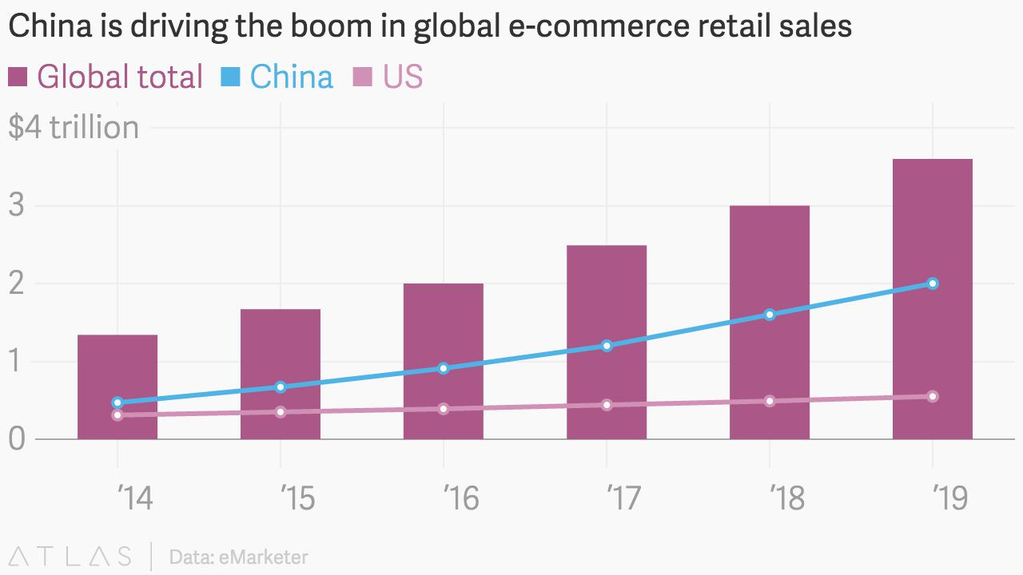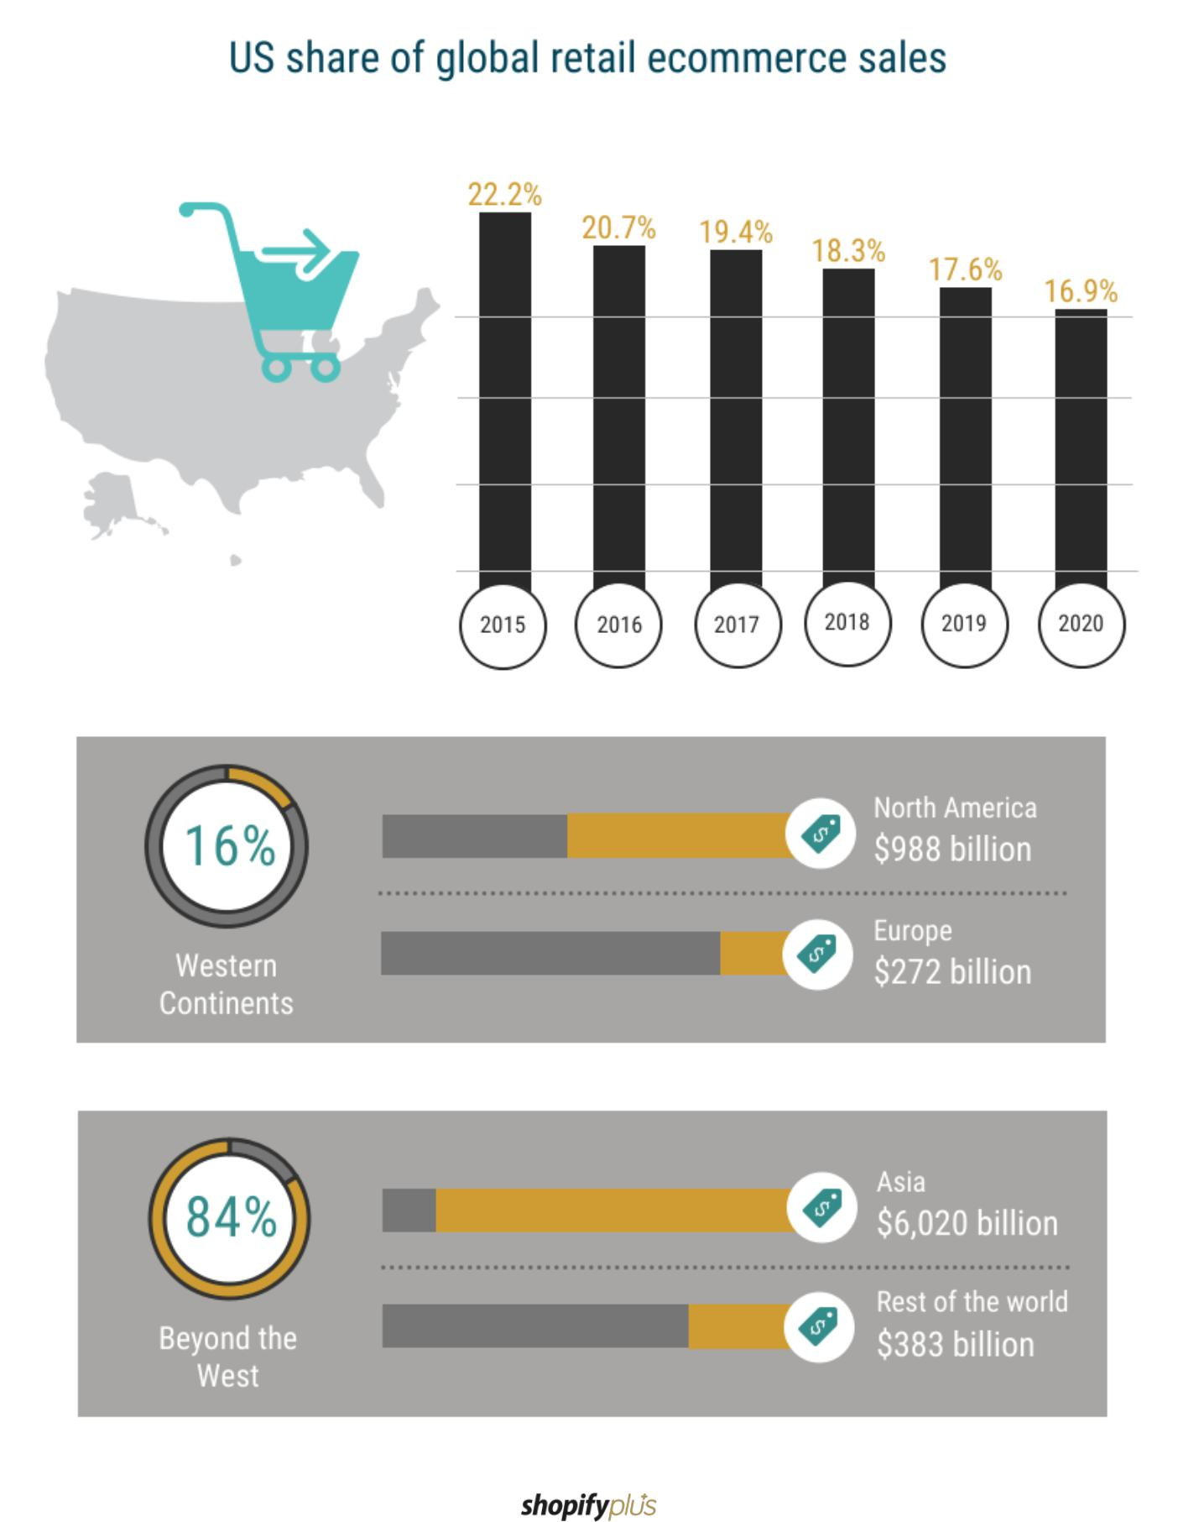

.

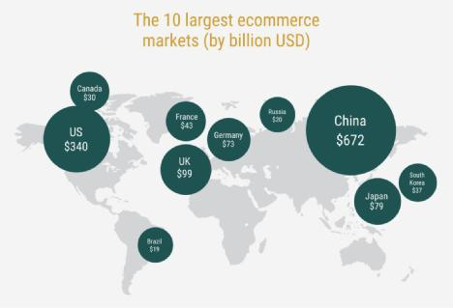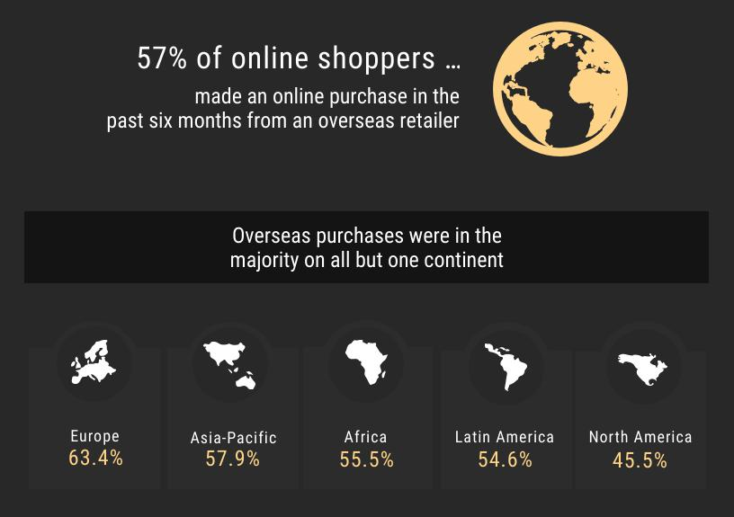

**Ever-Green Profitable Niches**

Health & Wellness

Baby-Care Products

Consumer electronics

Home Goods & Furniture

Fitness & Sports

Fashion & Apparel

Beauty Cosmetics

Toys & Games